A Selection of Seeds to Attract Butterflies to your Garden

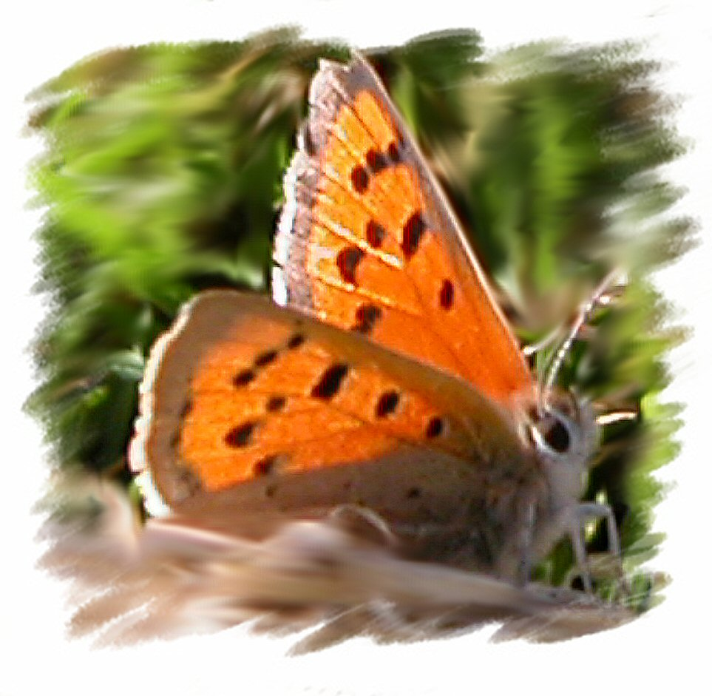
Please sow these seeds in your garden as a souvenir of our special day

