A Selection of Seeds to Attract Bees to your Garden

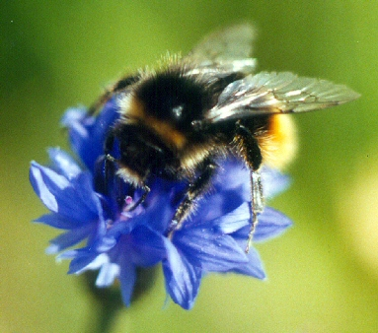

Please sow these seeds in your garden as a souvenir of our special day

